Contents
Introduction 2
Data Preparation 4
Descriptive Analysis 7
Analysis & Insights 10
Correlation and Outlier Analysis 14
Conclusion and Discussion 20
References 21

Introduction

The purpose of this study was to investigate holiday trends and traveller behaviour. As the summer period was just ending, I thought it would be a valid time to complete a survey. With today’s cost of living issues, I wanted to gauge if people are still willing to take summer holidays and get an understanding of the overall costs involved.
As part of the survey, I wanted to find out if people are still going overseas or preferring to stay in Ireland. Other areas of the survey were to look at the age range of respondents to get an understanding of how they book holidays and how much on average the holiday costs (overall and accommodation costs).

The survey was designed with Google Forms and called:
Recent Holiday Trends and Traveller Behaviour Survey

A link to the survey was issued to friends, family and fellow students on my Phone contacts. Everyone was notified that this survey was for academic purposes only and all responses will be anonymised.

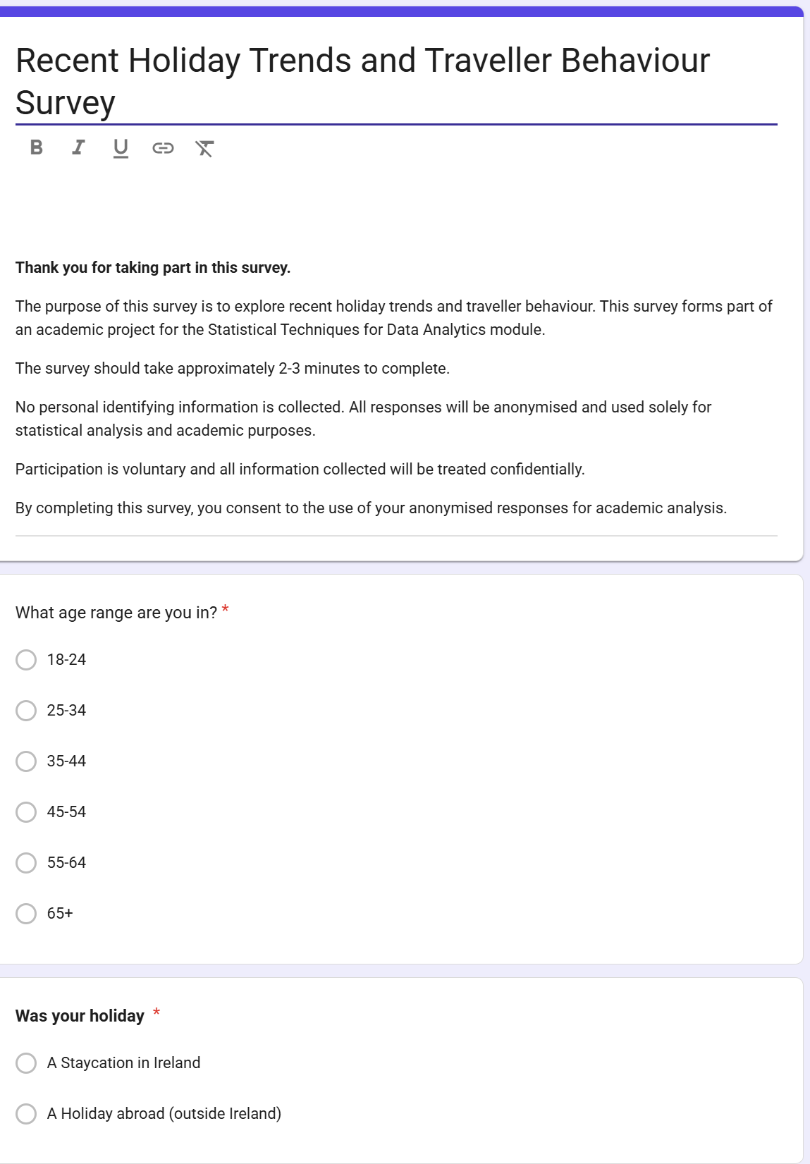
Figure 1 shows a snapshot of the Google Form

Data Preparation

The questions were designed in a way to give us data on:
- Categorical Variables
- Numerical Variables
- Likert Scale
- Boolean Variables

Data Preparation Actions
Once completed, I received 71 responses on Google Forms from my survey. This survey was downloaded as a CSV file and named:
Data_CA1.csv

The next stage was to clean the data, such as:
- Trim any leading spaces from the form
- Check for null values
- Check shape
- Check the information on loaded data
- Rename columns to make it more readable

No missing values were discovered on the dataset and was now ready for analysis.

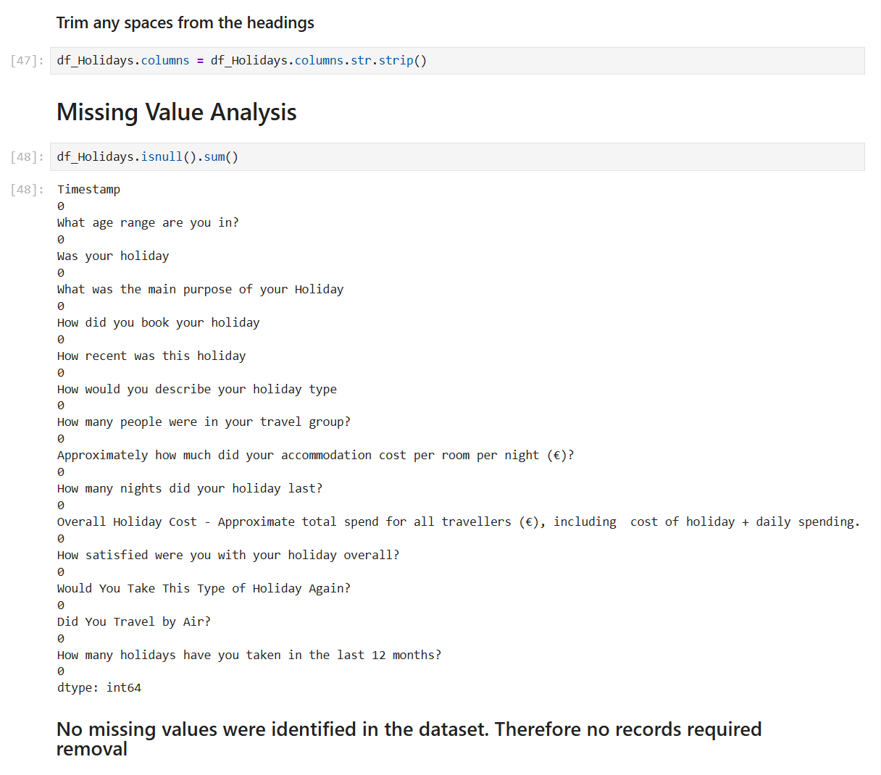
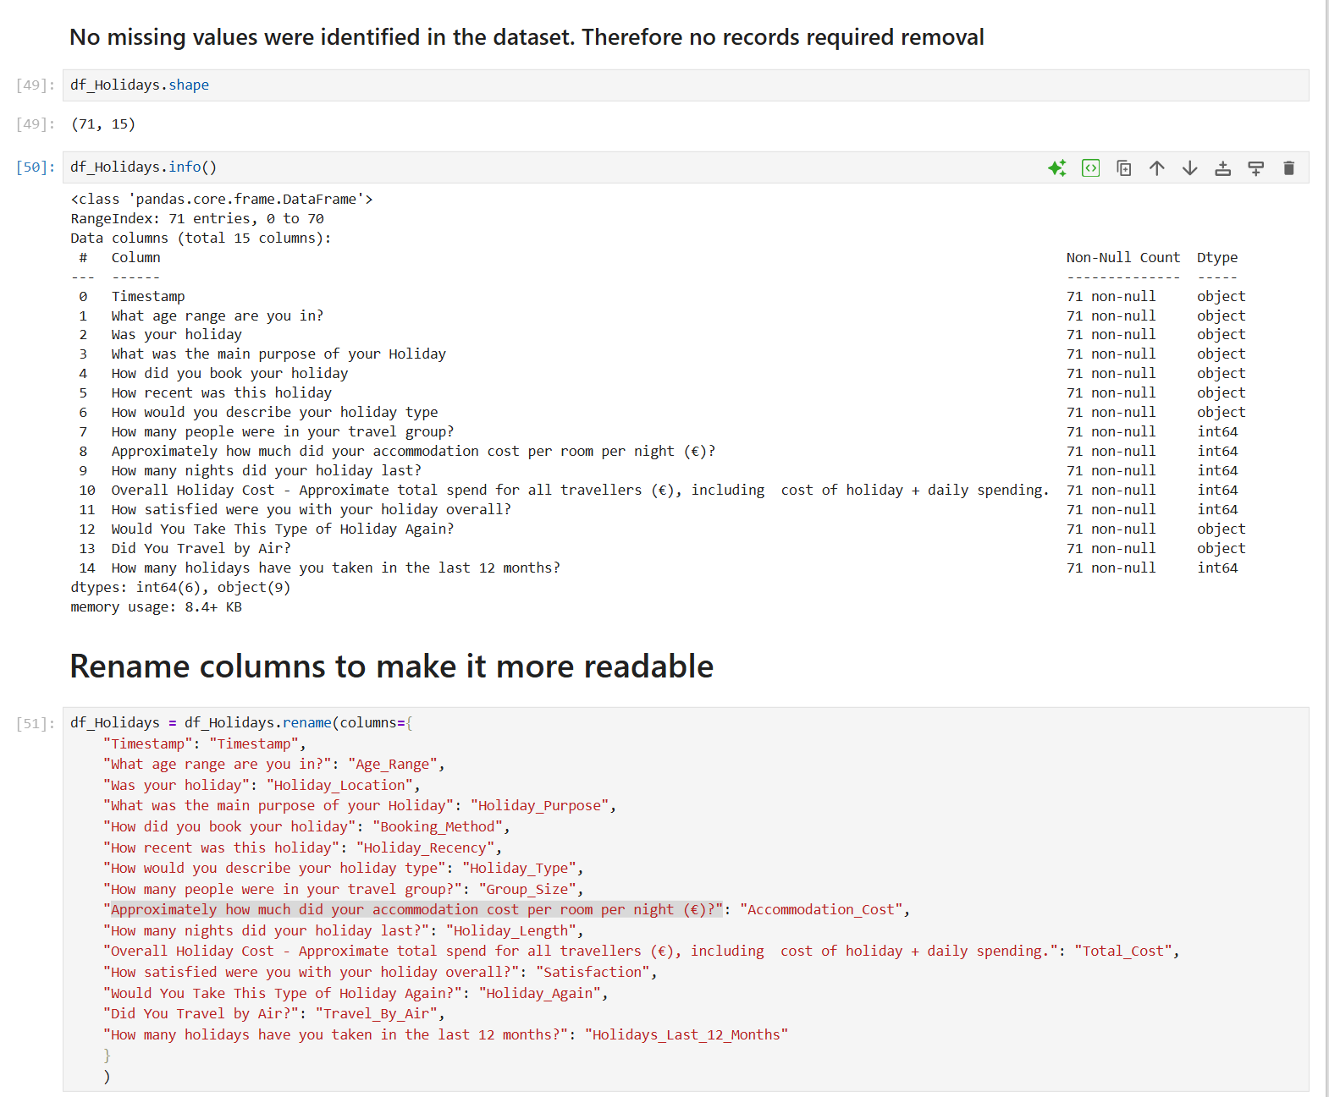

Descriptive Analysis
Descriptive statistics were carried out on the survey dataset to identify patterns from respondents.
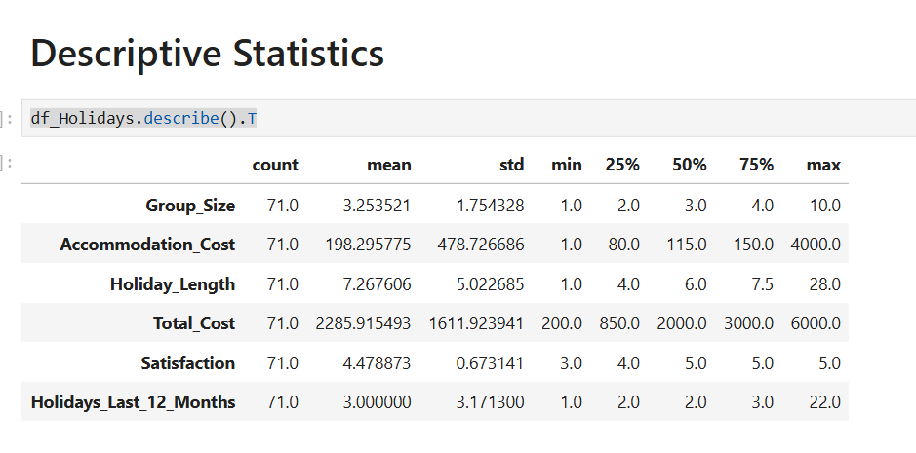
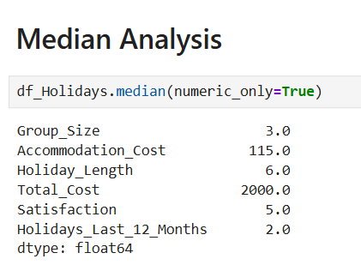

The average Accommodation cost (per night) was €198.29. However, the median analysis shows the accommodation cost of €115.00. This would suggest that the distribution is positively skewed due to a few unusually high accommodation costs. This is further supported with a max value of €4,000.
Skewness analysis was presented to understand the shape of the distributions. As expected, Accommodation Cost displayed a high positive skewness of 7.43, confirming a few extreme outliers.

The mean Holiday length showed as 7.26 days, whilst it showed a positive skewness of 2.55, again resulting an outlier, with a max value of 28 days, influencing the overall distribution.
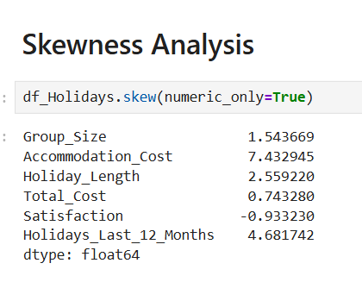
For a categorical Analysis, an age bar chart that was created shows that respondents were reasonably evenly distributed across the younger and middle-age categories. The 25–34 and 35–44 age groups represented the largest proportion of respondents, while the 65+ category contained the fewest responses.
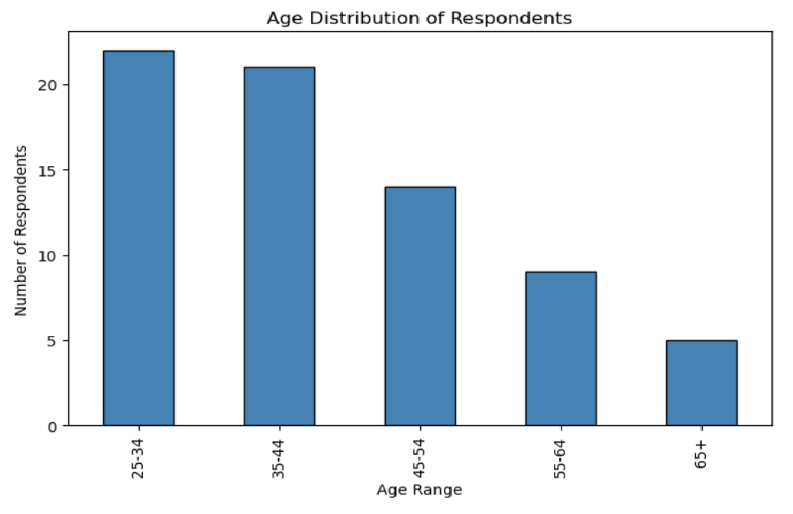

Online bookings were the most popular method, with approximately 78% of all bookings, as opposed to package holidays.
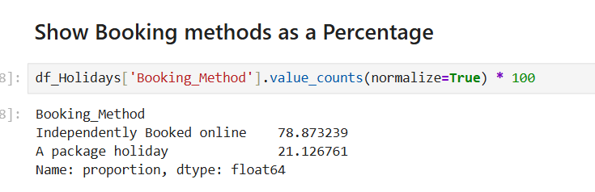
Beach holidays abroad were the most popular holiday type. This is not surprising as the survey took place immediately after the summer holiday season.
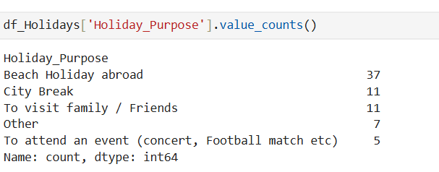

Overall, the descriptive statistics provided a better understanding of holiday spending patterns, satisfaction ratings and holiday types. However, we can see a few outliers in the dataset that warranted further investigation.

Analysis & Insights

Booking Methods by Age Range
See below: pivot table was created to give an analysis of Booking methods by age range.
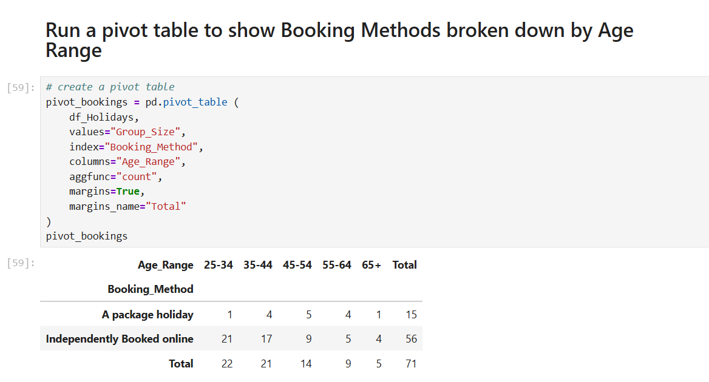

By breaking down Booking Methods by age range, we can see that online bookings remained the preferred choice of booking across all age categories, although package holidays were more common among the respondents aged 45-54.

A bar chart was used to further visualise the results

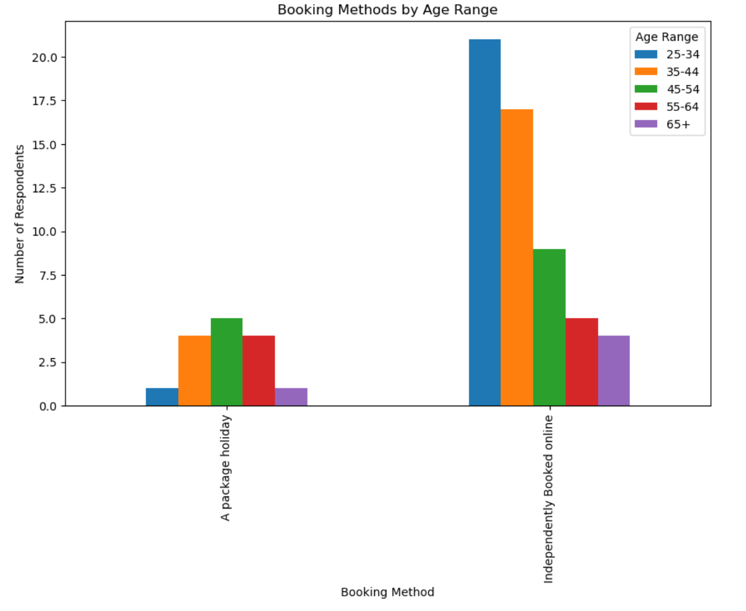

Relationship to Holiday Duration, Total Expenditure & overall Satisfaction

In this analysis, a scatterplot was used to visualise this multivariate analysis
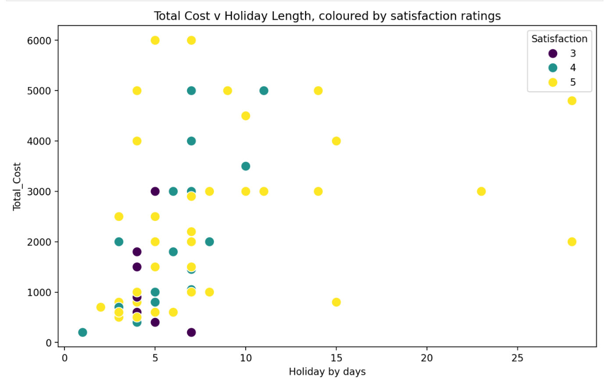

Scatterplot Analysis
The scatterplot shows a positive relationship between duration of holiday and total cost. However, a higher satisfaction rating can be observed across both low-cost and high-cost holidays.

Probability
A probability measurement was gathered to search the booking methods of the 25-34 age range. The prior probability shows:
P(A) Probability respondent is aged 25-34 = 30.99%
P(B) Probability respondent booked online independently = 78.87%

The conditional probability result of 37.5% was received when considering that a respondent was 25-34 when considering only the booking method. Bayes Theorem also produced a 37.5% result. This was higher than the overall proportion of respondents aged 25-34, suggesting that this age group was more likely to book holidays online.

Correlation and Outlier Analysis
A streamlined data frame was created along with a new derived variable called “Cost_Per_Night”. This was created by dividing Total_Cost by Holiday_Length and then dividing by Group_Size.

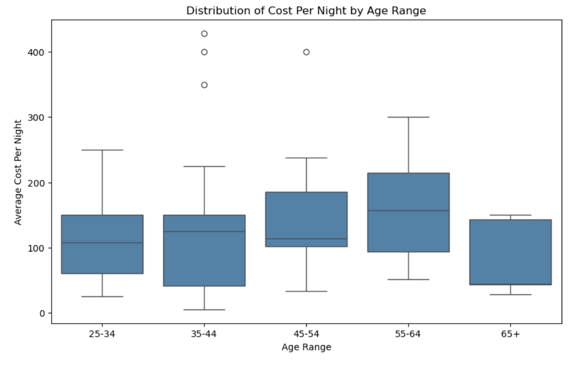
The presence of outliers helps explain why some age groups have noticeably higher mean values in the previous bar chart
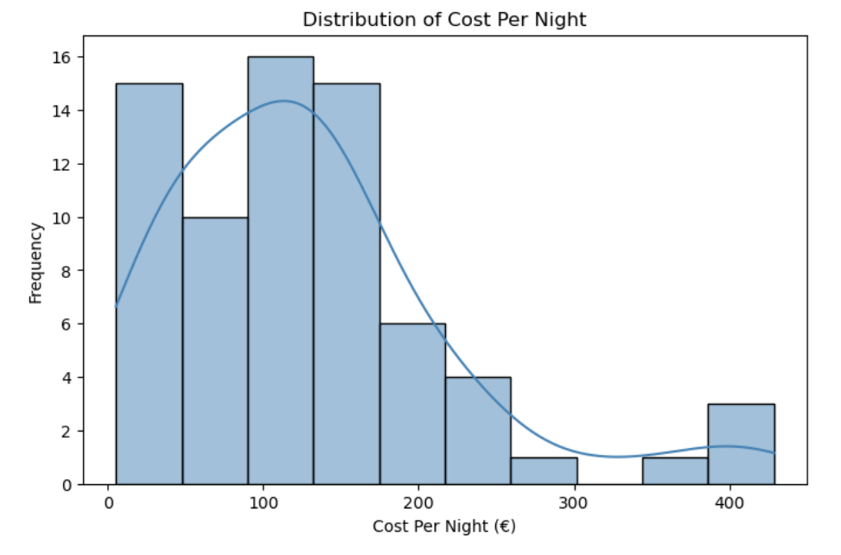
The histogram of Cost_Per_Night demonstrates a positively skewed distribution. Most respondents recorded a cost per night below €300, whilst a smaller number of respondents reported a significantly higher spending. The presence of these higher values creates a longer tail on the right-hand side of the distribution, indicating potential outliers.

Correlation Analysis
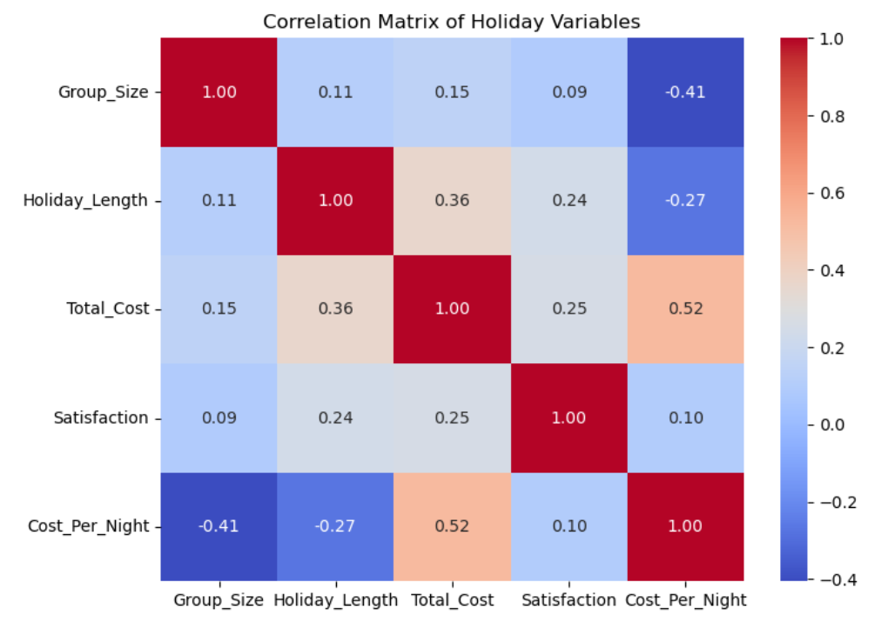

The strongest positive correlation was between Total_Cost and Cost_Per_Night (r=0.52). This indicates that respondents who spent more overall also tended to spend more on a per-night basis, which is to be expected.

Outlier Analysis using Accommodation Costs
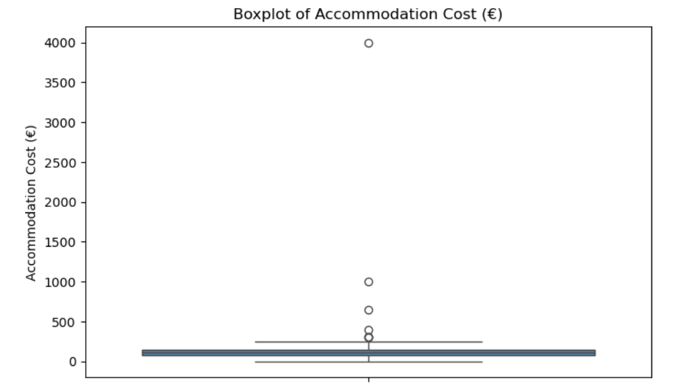
The Boxplot clearly shows the presence of several extreme accommodation costs.
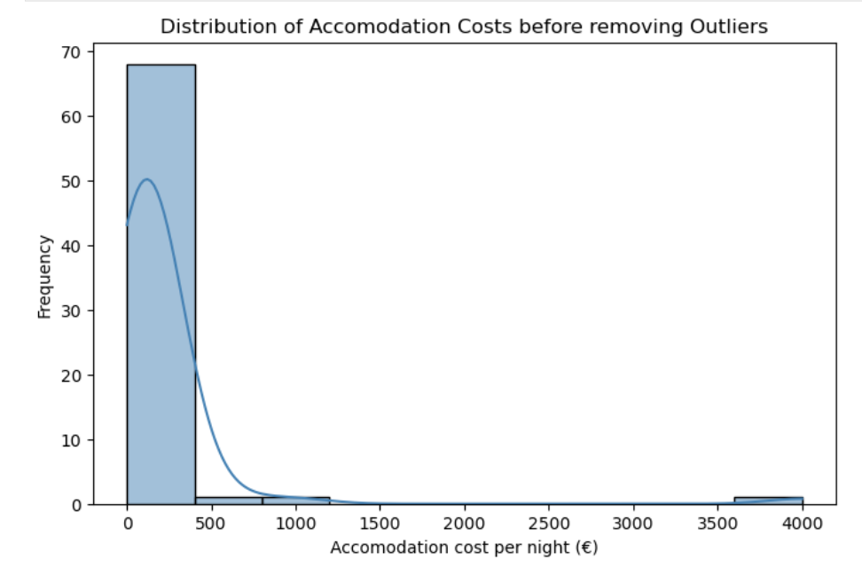

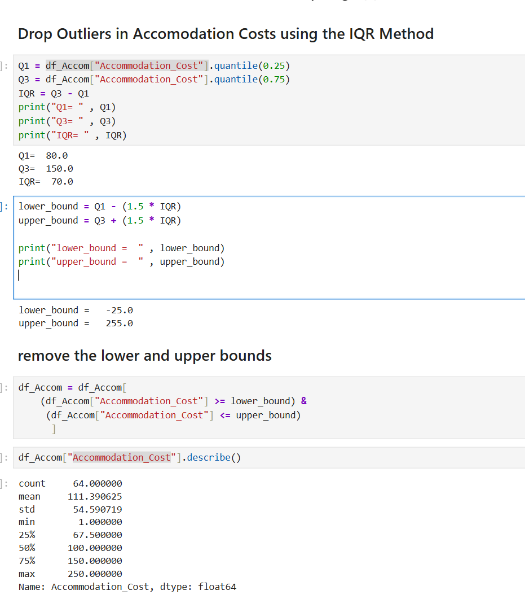
The mean accommodation costs of €111.39 are recorded after removal of outliers. The original dataset has a mean of €198.28 before removal of outliers. This further indicates that a small number of observations were increasing the average cost.

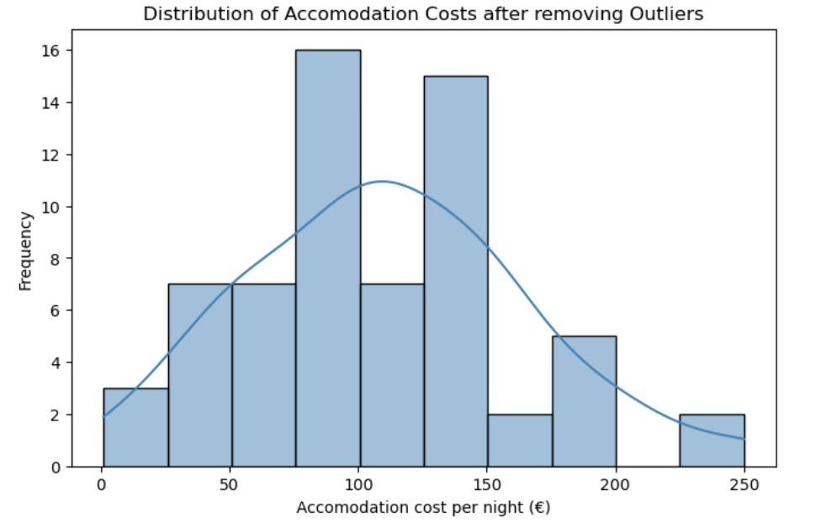

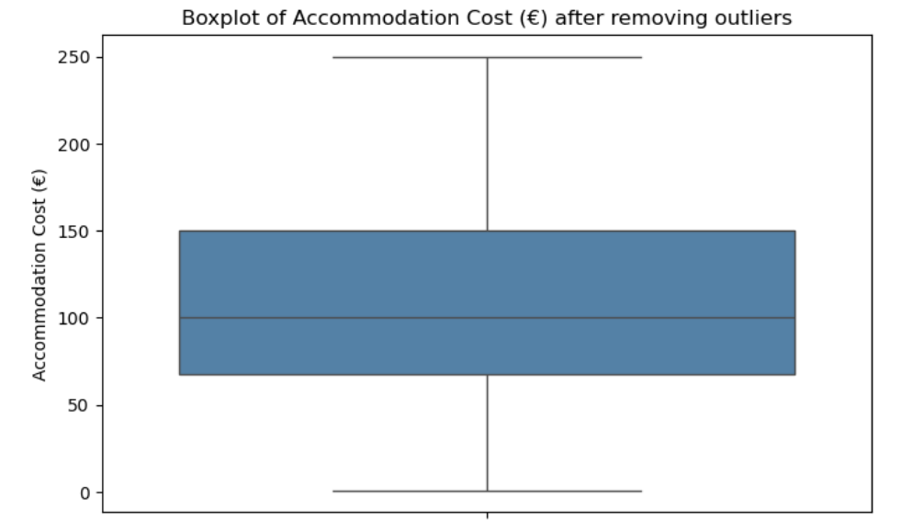

Using the IQR Method to identify outliers with the Accommodation Cost variable
- Q1 was 80
- Q3 was 150
- IQR was 70

By applying the standard 1.5 x IQR the upper bound was €255 and the lower bound was €-25 were calculated. Therefore, only Rows exceeding the upper bounds were classified as outliers and removed. This resulted in seven observations classified as outliers and removed, with a new dataset of 64 remaining.

Conclusion and Discussion

The analysis provided valuable insights into the Holiday Trends survey, showing us that online bookings were the preferred method across all age groups, while longer holidays resulted in higher expenditure. Satisfaction levels were high across the dataset, regardless of expenditure.
The impact of outliers on the Accommodation Cost variable was a main finding. Extreme values resulted in a positively skewed distribution. Once outliers were removed, using the IQR method, the distribution became more representative of typical accommodation costs.
Using Python and its libraries, a raw survey dataset and transform it into meaningful insights, through statistical analysis and data visualisation techniques, enabling trends and unusual observations to be identified.

References

CCT College Dublin (2026) Statistical Techniques for Data Analysis Module Notes. Available via Moodle
CCT College Dublin (2026) Data Preparation Module Notes. Available via Moodle
Microsoft 365 Copilot. Use for statistical concept explanations, Python debugging, report structuring and analytical support,
Udemy (2026) Python for Machine Learning & Data Science Masterclass. Available at: Udemy
Zero To Mastery (2026) Complete A.I. Machine Learning and Data Science: Zero to Mastery. Available at: Zero To Mastery

